Cloud formation update failures

Something goes wrong and it is automatically returns most recent successful state.

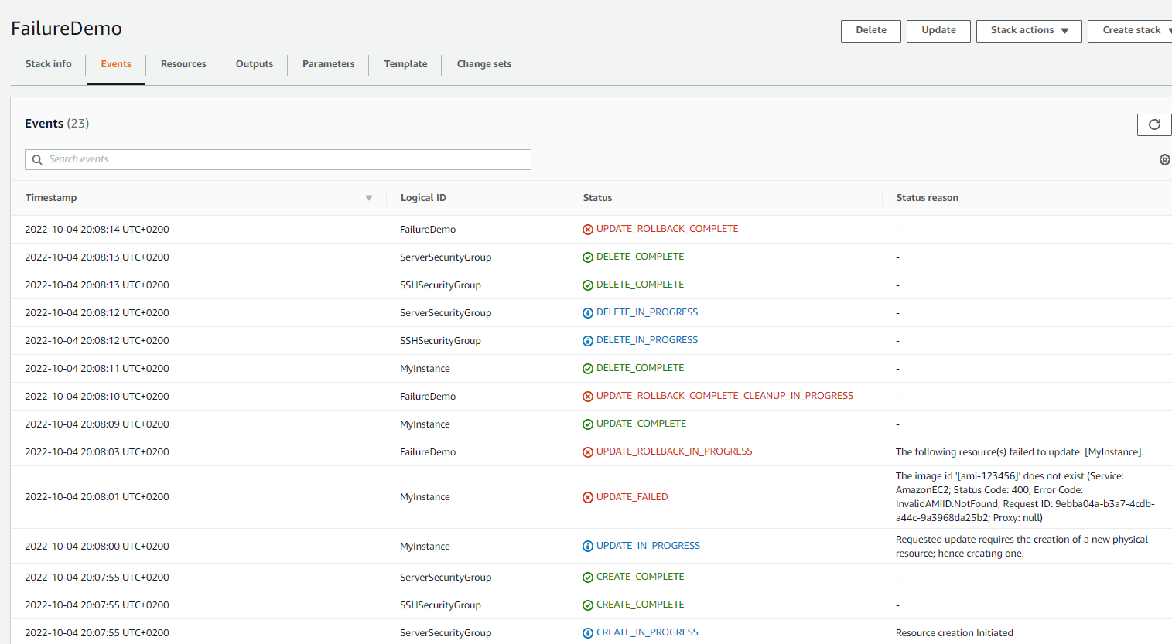

If you enable rollback on failure, then stack will be rolled back completely, and you cannot make changes on it. You can only delete it.

**CloudFormation drift**

First we create stack, then we make some changes manually

